# WEDDING PLANNER WEBSITE

**A PROJECT REPORT**

**for**

**Mini Project-I (K24MCA18P) Session (2024-25)**

**Submitted by**

**GARGI GUPTA**

**(202410116100071)**

**MANSI GARG**

**(202410116100116)**

**HARSHITA CHAUHAN**

**(20241011610009)**

**Submitted in partial fulfilment of the**

**Requirements for the Degree of**

# MASTER OF COMPUTER APPLICATION

**Under the Supervision of**

**Mr. Arpit Dogra**

**Assistant Professor**



**DEPARTMENT OF COMPUTER APPLICATIONS**

**KIET Group of Institutions, Ghaziabad**

**Uttar Pradesh-201206**

**( DECEMBER-2024)**

# DECLARATION

We hereby declare that the work presented in this report entitled **“ WEDDING PLANNER WEBSITE",** was carried out by us. We have not submitted the matter embodied in this report for the award of any other degree or diploma of any other University or Institute. We have given due credit to the original authors/sources for all the words, ideas, diagrams, graphics, computer programs, experiments, results, that are not my original contribution. We have used quotation marks to identify verbatim sentences and given credit to the original authors/sources. We affirm that no portion of my work is plagiarized, and the experiments and results reported in the report are not manipulated. In the event of a complaint of plagiarism and the manipulation of the experiments and results, We shall be fully responsible and answerable.

**Name** **:**  **Gargi Gupta** (202410116100071)

**Mansi Garg** (202410116100116)

**Harshita Chauhan** (202410116100090)

**Branch :** **MCA**

(Candidate Signature)

**2**  **|** P a g e

# CERTIFICATE

Certified that **Gargi Gupta 202410116100071, Harshita Chauhan 202410116100091, Mansi Garg 202410116100116** has/ have carried out the project work having “**Wedding Planner Website**” (**Mini Project-I, K24MCA18P**) for **Master of Computer Application** from Dr. A.P.J. Abdul Kalam Technical University (AKTU**)** (formerly UPTU), Lucknow under my supervision. The project report embodies original work, and studies are carried out by the student himself/herself and the contents of the project report do not form the basis for the award of any other degree to the candidate or to anybody else from this or any other University/Institution.

**Mr. Arpit Dogra Dr. Arun Kr. Tripathi**

**Assistant Professor Dean**

**Department of Computer Applications Department of Computer Applications**

**KIET Group of Institutions, Ghaziabad KIET Group of Institutions, Ghaziabad**

**3**  **|** P a g e

# WEDDING PLANNER WEBSITE

**GARGI GUPTA**

**MANSI GARG**

**HARSHITA CHAUHAN**

# ABSTRACT

A wedding planner website serves as a one-stop solution for couples to streamline the complex process of planning their dream wedding. This platform offers a personalized and user-friendly interface to manage every aspect of the event, including venue selection, catering, décor, photography, and entertainment. Users can choose from predefined packages or customize their wedding plan to suit their preferences and budget. The website integrates advanced tools such as a dynamic timeline for task management, vendor directories with reviews, and secure payment gateways, ensuring a seamless experience.

Key features include a comprehensive dashboard to track progress, reminders for upcoming tasks, and real-time communication with vendors. Vendors benefit from increased visibility and booking management, while users enjoy stress-free planning with minimal effort. Additionally, data-driven insights and reports enable administrators to monitor user engagement, track revenue, and optimize offerings.

By incorporating advanced technology and user-centric design, the wedding planner website bridges the gap between couples and service providers, creating an efficient and collaborative ecosystem. It also emphasizes convenience, personalization, and transparency, which are critical to ensuring client satisfaction.

Keywords: Wedding Planning, Vendor Management, Event Customization, User Dashboard, Task Management

**ACKNOWLEDGEMENTS**

Success in life is never attained single-handedly. My deepest gratitude goes to my project supervisor, **Mr. Arpit Dogra** for her guidance, help, and encouragement throughout my project work. Their enlightening ideas, comments, and suggestions.

Words are not enough to express my gratitude to Dr. Arun Kumar Tripathi, Professor and Dean, Department of Computer Applications, for his insightful comments and administrative help on various occasions.

Fortunately, I have many understanding friends, who have helped me a lot on many critical conditions.

Finally, my sincere thanks go to my family members and all those who have directly and indirectly provided me with moral support and other kind of help. Without their support, completion of this work would not have been possible in time. They keep my life filled with enjoyment and happiness.

Gargi Gupta

Mansi Garg

Harshita Chauhan

# TABLE OF CONTENTS

Page Number

1. Declaration 2
2. Certificate 3
3. Abstract 4
4. Acknowledgement 5
5. Introduction 6
6. Literature Review 7-9
7. Project / Research Objective 9-12
8. Hardware and Software Requirements 12-13
9. Project Flow 14
10. ER Diagram 15
11. Project 16
12. Data Flow Diagram 16-19
13. Project ScreenShots 19-24
14. Use Case Diagram 24-26
15. Proposed Time Duration 26
16. References/ Bibliography 27

**INTRODUCTION**

A wedding is one of the most cherished milestones in a person's life, and planning for this special day often involves significant effort, coordination, and attention to detail. The Wedding Planner Website is designed to streamline and simplify this process, offering a one-stop platform for organizing weddings efficiently and seamlessly.

This website acts as a virtual wedding planning assistant, enabling users to manage every aspect of the event, from budgeting and guest list creation to venue selection and vendor coordination. By leveraging intuitive design, advanced features, and personalization options, the platform provides an easy-to-use and accessible solution tailored to meet the diverse needs of couples and their families.

The website is ideal for users who want to save time, reduce stress, and ensure their wedding day runs smoothly. With interactive tools, reminders, and expert suggestions, the Wedding Planner Website empowers users to plan their perfect day with confidence and ease. Whether for small intimate ceremonies or grand celebrations, this platform caters to a wide range of requirements, ensuring that no detail is overlooked.

By integrating modern technology with thoughtful design, the Wedding Planner Website aims to revolutionize how weddings are planned, making the journey to "I do" as enjoyable as the day itself.

# 

# LITERATURE REVIEW

The wedding industry has experienced significant growth over the past few decades, with technology playing an increasingly important role in transforming how weddings are planned and executed. Traditional wedding planning, which involved physical consultations, manual coordination, and paper-based organization, has gradually evolved into a more streamlined, digital process. This literature review examines existing research, applications, and advancements in the field of wedding planning, highlighting the importance of digital platforms in revolutionizing this process.

**1. Emergence of Technology in Event Planning**

The rise of technology has greatly impacted event planning, including weddings. According to Turner and Spear (2018), digital platforms have reduced the complexity of managing large-scale events by centralizing communication, task management, and financial tracking. Platforms such as online marketplaces and digital tools for planning have enabled couples to make informed decisions by providing instant access to information about vendors, venues, and pricing.

Wedding-specific platforms like *The Knot*, *Zola*, and *WeddingWire* have emerged as key players in the market, offering a variety of tools such as budget calculators, RSVP tracking, and vendor directories. These platforms have made it easier for couples to organize and plan their weddings without requiring professional planners. However, research indicates a gap in personalization and seamless integration of multiple services, which leaves room for innovation in wedding planning solutions (Chaudhary, 2020).

**2. Role of Digital Tools in Wedding Planning**

Studies indicate that digital tools help reduce stress and improve efficiency during wedding planning. Research by Smith et al. (2020) found that over 85% of couples use at least one wedding planning app or website during their planning process. Tools like budgeting calculators, timeline creators, and guest list management systems were highlighted as critical features that reduce the time and effort needed to organize events.

Furthermore, Gupta and Sharma (2019) suggest that incorporating artificial intelligence (AI) and machine learning can further enhance the user experience by offering personalized recommendations for themes, venues, and vendors based on user preferences and budgets.

**3. Online Vendor Management and Marketplaces**

Vendor selection and management remain among the most challenging aspects of wedding planning. Online vendor directories have emerged as a popular solution, allowing users to browse and compare vendors based on reviews, prices, and services offered. However, research by Park and Lee (2021) highlights challenges such as lack of transparency, fake reviews, and limited availability of real-time vendor updates.

Integrating verified vendor partnerships and offering real-time communication tools have been proposed as solutions to address these limitations. Furthermore, blockchain technology could be used to ensure transparency and security in vendor contracts and payments (Sharma & Verma, 2021).

**4. User Experience and Personalization in Wedding Planning**

User experience (UX) is a critical factor in the success of digital wedding planning platforms. Research by Kim and Brown (2019) emphasizes the importance of intuitive design, easy navigation, and visually appealing interfaces in creating a positive user experience. Personalized features, such as custom templates for invitations and recommendations based on cultural or regional preferences, significantly enhance user satisfaction.

Despite existing efforts, a lack of inclusivity for diverse cultural practices and traditions is a notable limitation in many existing platforms.

# OBJECTIVES

**Objective of the Wedding Planner Website**

Planning a wedding is a monumental task that involves countless details, multiple stakeholders, and a great deal of emotional and financial investment. The Wedding Planner Website is designed to act as a comprehensive digital assistant for couples, families, and wedding organizers, simplifying the planning process while ensuring every detail is managed seamlessly.

The primary objective of the platform is to provide an intuitive, centralized hub for planning weddings of all scales, from intimate ceremonies to large-scale celebrations. By integrating advanced technology with thoughtful design, the website addresses the challenges faced during wedding planning and offers practical, efficient solutions tailored to the unique needs of each user.

**Key Objectives:**

1. **Centralized Planning Hub**:
   * The platform consolidates all wedding planning tasks into one easily accessible location.
   * It enables users to manage their budget, create and track to-do lists, schedule events, and organize guest lists in a structured and efficient manner.
   * Users can access all essential tools, documents, and resources in one place, eliminating the need for scattered spreadsheets or multiple apps.
2. **Time and Stress Management**:
   * The website aims to reduce the time and effort involved in coordinating a wedding by offering automated features like reminders, task prioritization, and progress tracking.
   * It minimizes stress by breaking down the planning process into manageable steps, guiding users with timelines and expert tips to keep them on track.
3. **Personalization and Customization**:
   * Every wedding is unique, and the platform supports this by allowing users to personalize their experience.
   * It provides customizable templates for wedding themes, invitations, seating arrangements, and itineraries to match the couple’s preferences and style.
4. **Budget Management and Cost Efficiency**:
   * The platform includes detailed budgeting tools to help users set financial limits and track expenses.
   * Users can compare vendor pricing, identify cost-saving options, and receive real-time updates on their spending to ensure they stay within budget without compromising on quality.
5. **Vendor and Resource Integration**:
   * To simplify vendor selection, the platform integrates a curated directory of venues, caterers, photographers, decorators, and more.
   * It provides ratings, reviews, and contact details to help users make informed decisions and communicate directly with vendors.
   * The platform also includes tools for contract management and payment tracking.
6. **Guest Management**:
   * The website offers features for managing guest lists, including RSVP tracking, meal preferences, and seating arrangements.
   * Users can send digital invitations and updates to guests, ensuring smooth communication and coordination.
7. **Collaboration and Sharing**:
   * Wedding planning often involves collaboration between family members, friends, and vendors. The platform allows multiple users to access and contribute to the planning process in real-time.
   * Shared access enables teams to work together efficiently, whether it’s finalizing decorations or coordinating logistics.
8. **Enhanced User Experience**:
   * The platform prioritizes user-friendly design, ensuring smooth navigation and ease of use for all users, regardless of technical expertise.
   * With a clean interface and intuitive functionality, the website makes the process of wedding planning enjoyable and stress-free.
9. **Inclusivity and Flexibility**:
   * The platform is built to cater to a diverse audience, accommodating different cultural, religious, and personal preferences.
   * It also offers flexibility to handle both traditional and unconventional weddings, ensuring inclusivity for all types of celebrations.
10. **Memorable Experience**:
    * Beyond functionality, the Wedding Planner Website strives to make the planning journey an exciting and joyful experience for couples.
    * By offering inspirational ideas, expert advice, and milestone tracking, it ensures that users focus on the excitement of their big day rather than the stress of planning.

# 

# HARDWARE AND SOFTWARE REQUIRMENT

**1. Hardware Requirements**

**For End-Users (Clients):**

* **Device**: Any device with internet access, such as:
  + Desktop or Laptop (Windows, Mac, Linux)
  + Smartphone (Android or iOS)
  + Tablet
* **Specifications**:
  + Minimum Processor: 1 GHz (Dual-Core or higher recommended)
  + RAM: 2 GB or higher
  + Storage: 200 MB free space for browser cache or mobile app storage
  + Display Resolution: 1280 x 720 pixels (HD) or higher for optimal viewing

**For Development and Hosting (Server-Side):**

* **Development Environment**:
  + Processor: Intel i5/i7 or AMD Ryzen equivalent (Quad-Core or higher)
  + RAM: 8 GB (16 GB recommended for seamless multitasking)
  + Storage: 512 GB SSD (Solid State Drive) for faster performance
* **Hosting Server**:
  + Processor: 2.4 GHz Quad-Core or higher
  + RAM: Minimum 8 GB (16 GB or more recommended for high traffic)
  + Storage: 500 GB SSD or higher, depending on the scale of the application
  + Bandwidth: 1 Gbps for high-speed data transfer
  + Operating System: Linux (preferred) or Windows Server
  + Uptime: 99.9% uptime guarantee for reliable service

**2. Software Requirements**

**For Development:**

1. **Programming Languages and Frameworks**:
   * **Frontend**:
     + HTML5, CSS3, JavaScript
     + Frameworks: React.js, Angular, or Vue.js for building interactive user interfaces
   * **Backend**:
     + Java (with Spring Boot)
     + Alternatively: Node.js, Python (Django/Flask), or PHP (Laravel)
2. **Database**:
   * MySQL, PostgreSQL, or MongoDB for storing user data, guest lists, and vendor information
3. **Development Tools**:
   * IDE: IntelliJ IDEA, Eclipse (for Java), or Visual Studio Code
   * Version Control: Git (with GitHub or GitLab for repository management)
   * Testing Tools: Selenium (for automation testing), Postman (for API testing), and JUnit (for unit testing)

# PROJECT FLOW

**Requirement Analysis**

* Requirement analysis is a crucial phase in the development of the Wedding Planner Website, as it defines the functional and non-functional needs of the system. The purpose is to understand the end-user expectations, technical requirements, and business goals to create a robust, user-centric platform. This document analyzes the functional, non-functional, and user requirements, along with the constraints, to ensure a seamless development process.**Functional**: Search flights, book tickets, payment integration, booking management (cancellations, reschedules).
* **Functional Requirements**
* **Non-Functional**: Security, scalability, and performance.
* **Database**: Design tables (e.g., flights, bookings).
* **Architecture**: Client-server model with a web interface and backend APIs. • **UI**: User-friendly design with flight search and booking functionalities.

**Implementation**:

* Develop the frontend (HTML, CSS, JavaScript). • Backend logic (Java).

**Testing & Validation**:

* **Functional**: Test booking, payment, and cancellation.
* **Security**: Test for vulnerabilities.
* **Performance**: Test system scalability and responsiveness.

**Deployment**:

Launch on a production server, ensuring all components are connected and working live.

**Maintenance**:

Monitor, fix bugs, and add enhancements based on user feedback.

## ER DIAGRAM OF WEDDING PLANNER WEBSITE

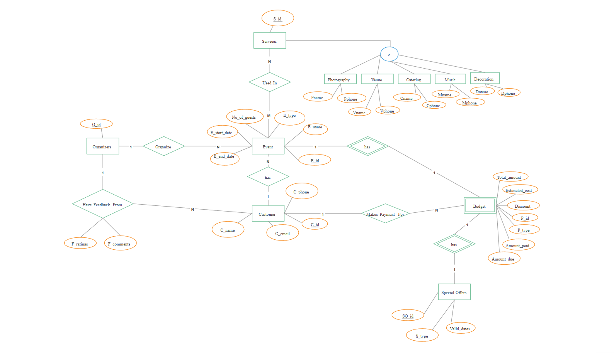

**FIGURE: 1**

# PROJECT

**User Interface**: Easy booking, and management.

**Admin Panel**: Manage Events and bookings.

**Payment Integration**: Secure online payment processing.

**Efficient Database**: Store and manage flight and booking data.

**Scalability & Security**: High performance and data protection.

**Responsive Design**: Works across all devices.

**System Optimization**: Fast, secure, and user-friendly experience.

# DATA FLOW DIAGRAM OF WEDDING PLANNER WEBSITE

**DFD LEVEL : 1**

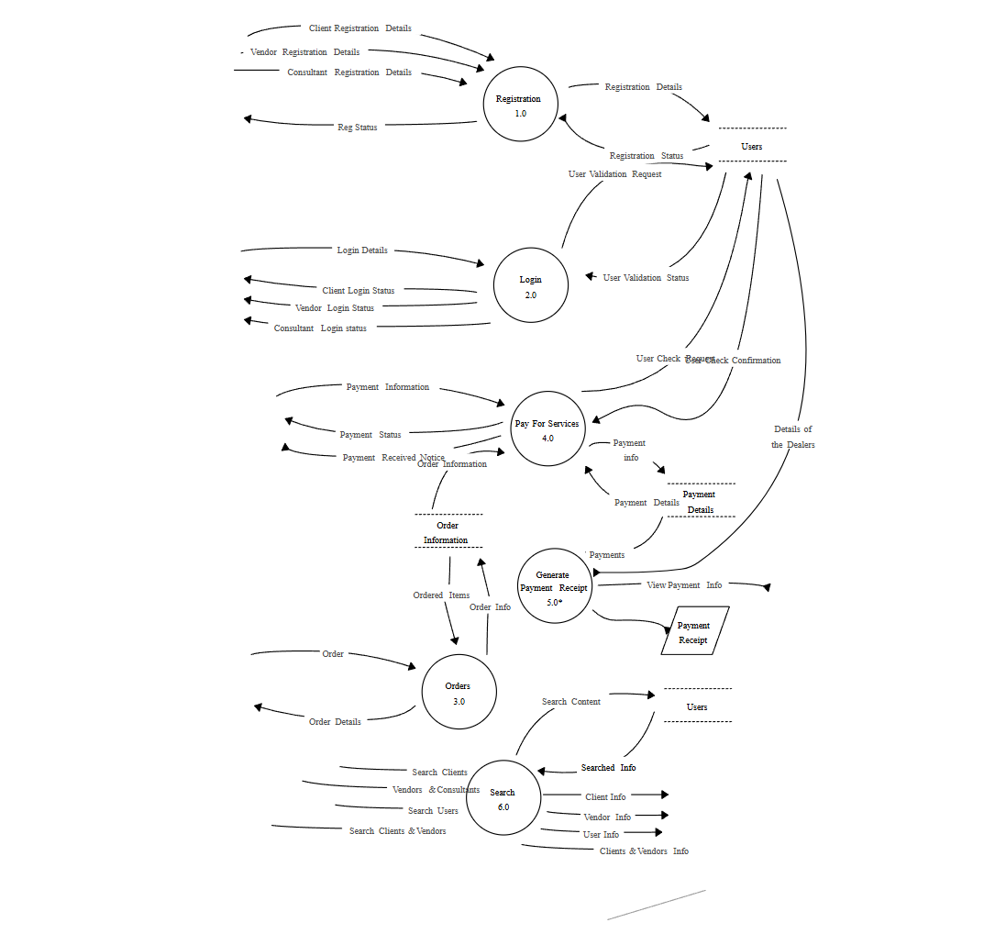

**FIGURE: 2**

**DFD LEVEL: 2**

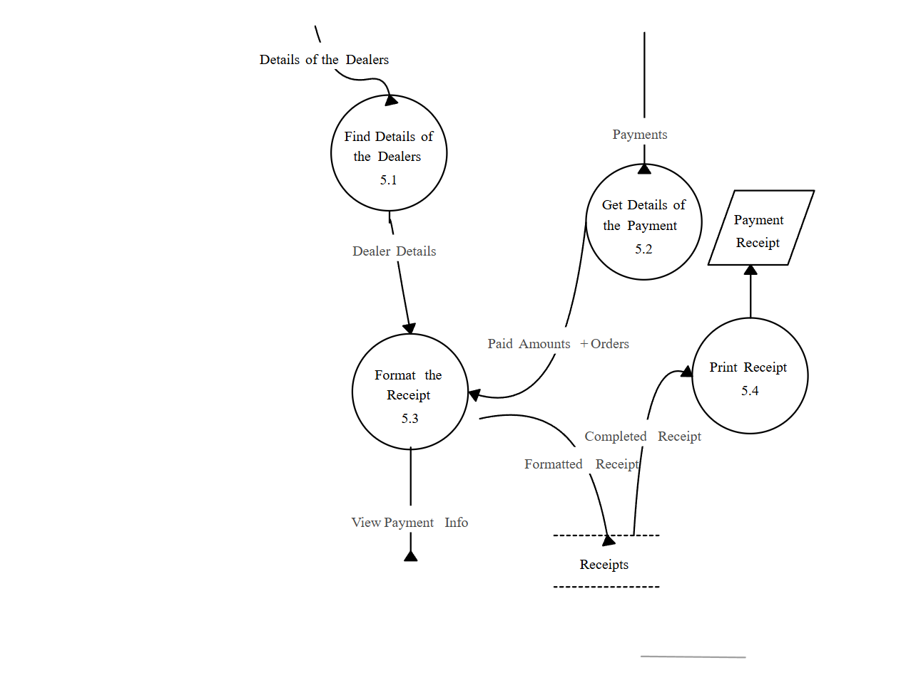

**FIGURE: 3**

# PROJECT SCREENSHOTS

# HOME PAGE :

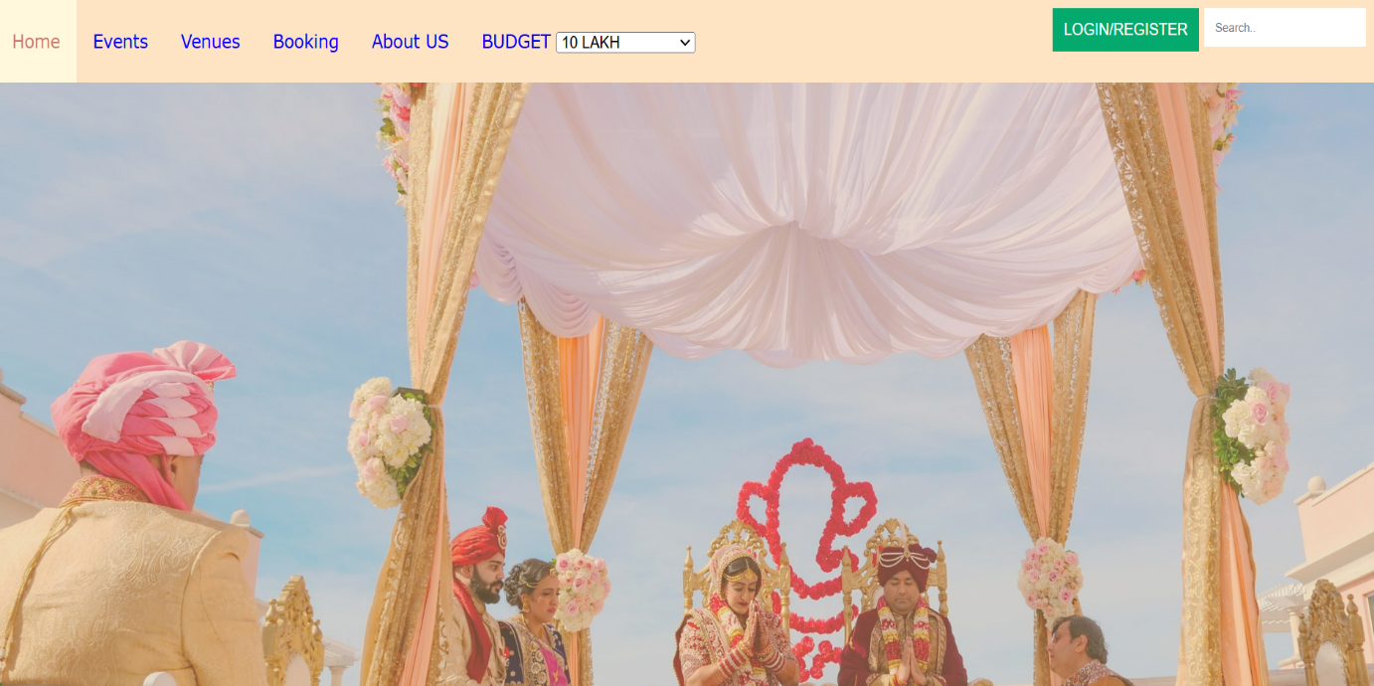

**FIGURE : 4**

**CUSTOMER SIGN IN PAGE :**

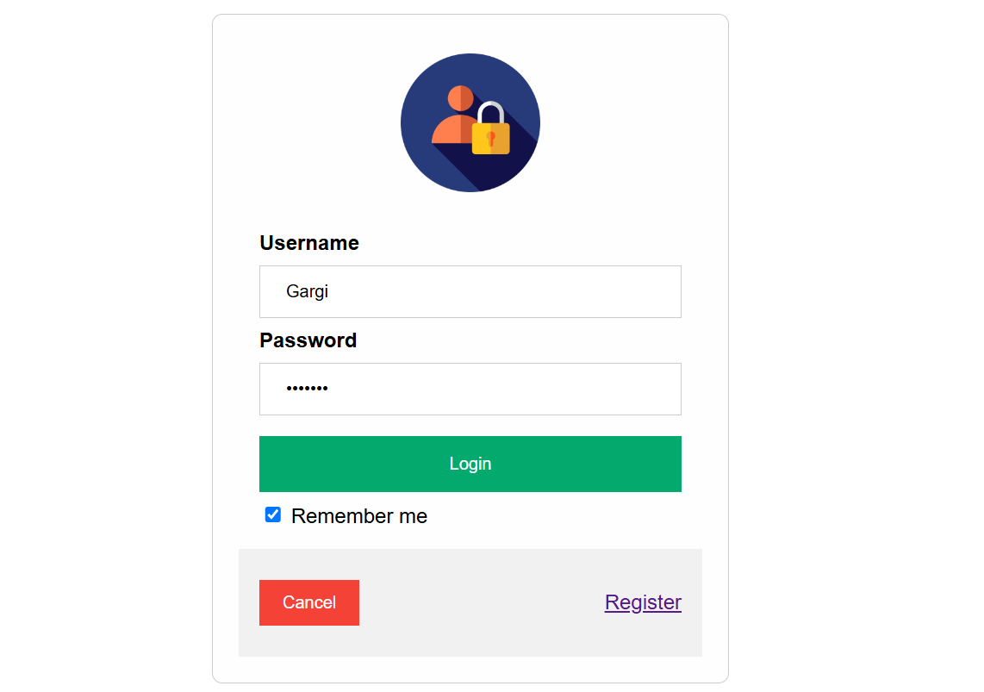

**FIGURE : 5**

**EVENTS PAGE :**

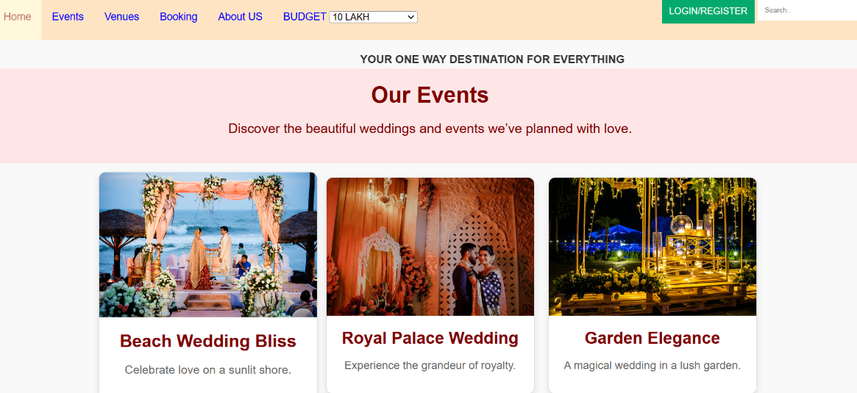

**FIGURE : 6**

**VENUES PAGE :**

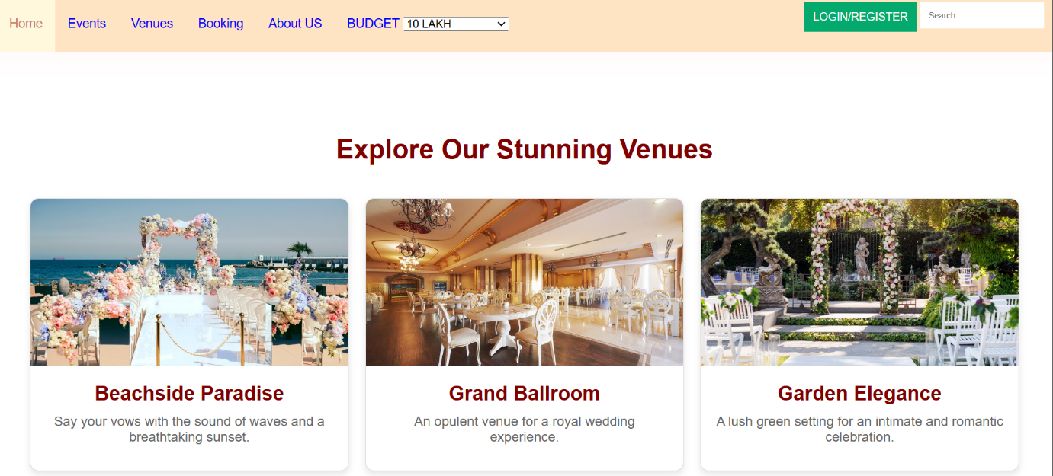

**FIGURE : 7**

**BOOKING PAGE :**

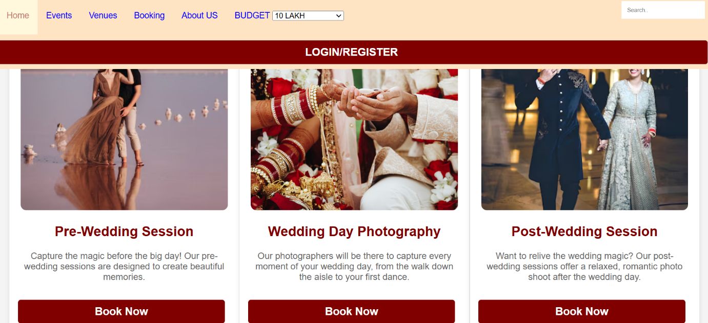

**FIGURE : 8**

**ABOUT US :**

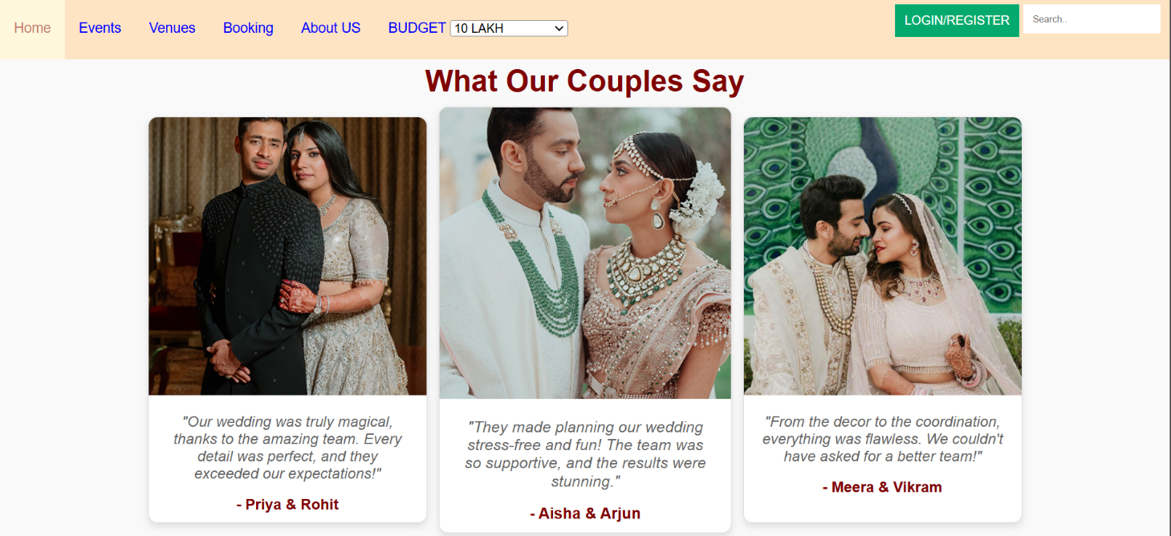

**FIGURE : 9**

**REGISTRATION PAGE:**

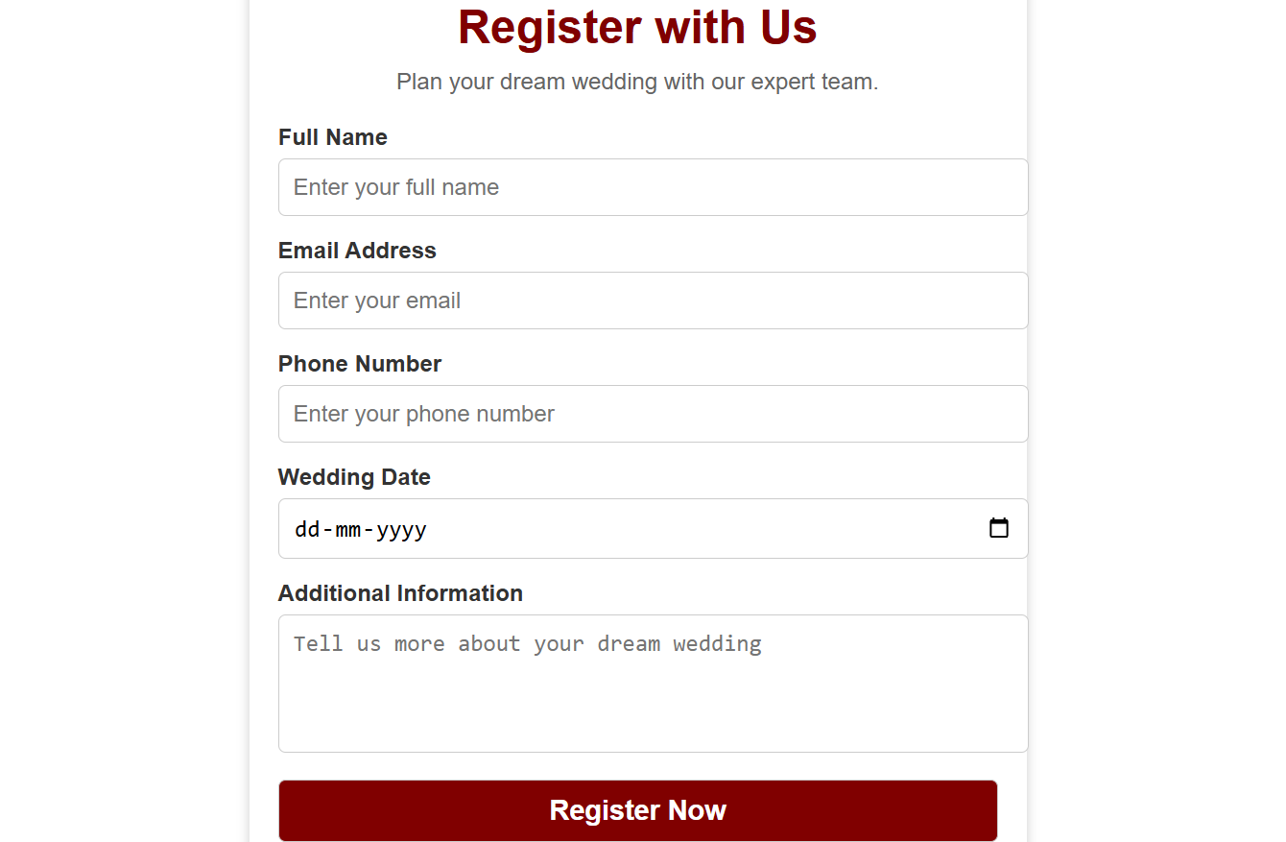

**FIGURE : 10**

# BACKEND DATA

**LOGIN DATA:**

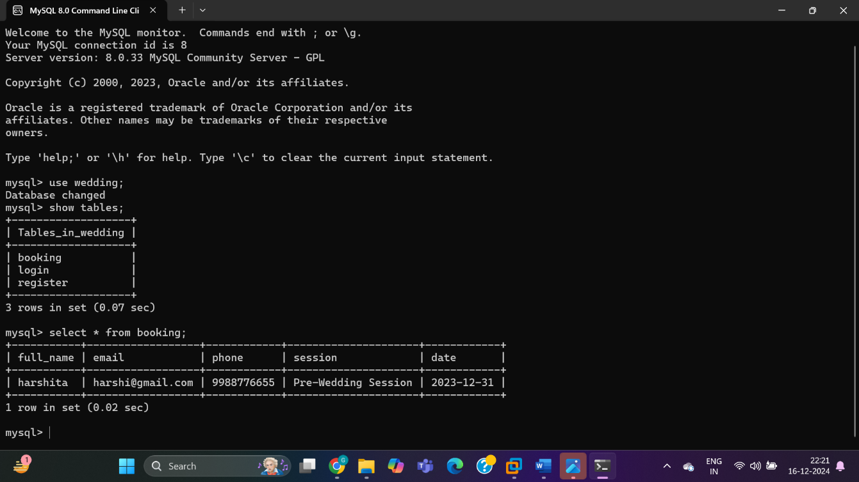

**FIGURE : 11**

**SESSION BOKKING DATA**

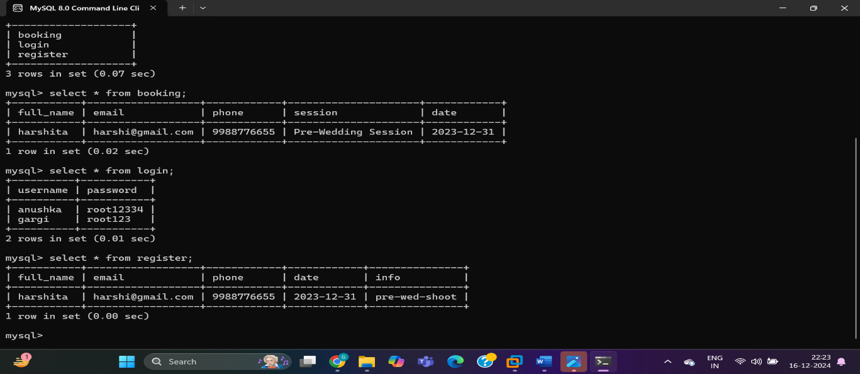

**FIGURE :12**

## COLLABORATION DIAGRAM OF WEDDING PLANNER WEBSITE

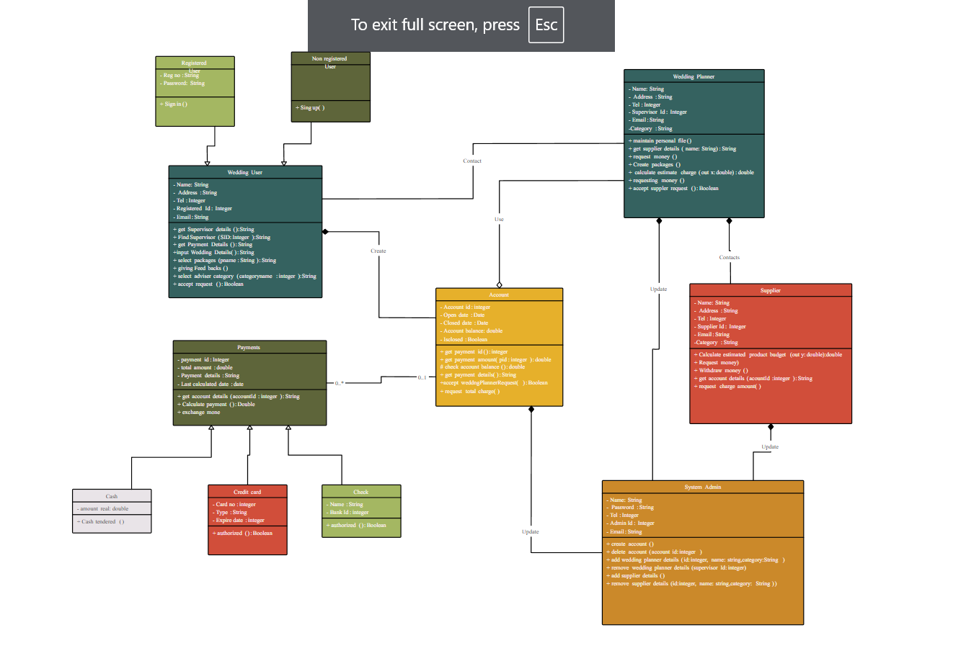

**FIGURE : 13**

**USE CASE DIAGRAM IN WEDDING PLANNER WEBSITE**

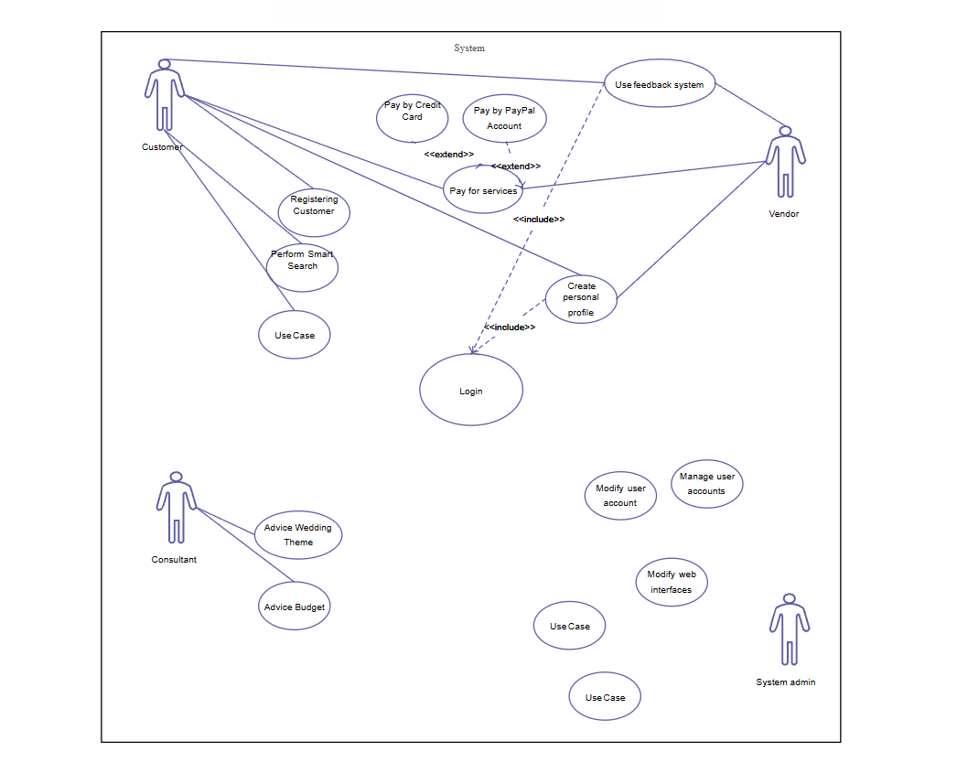

**FIGURE:14**

# PROPOSED TIME DURATION

|  |  |  |  |  |  |  |  |  |  |  |  |  |  |  |  |
| --- | --- | --- | --- | --- | --- | --- | --- | --- | --- | --- | --- | --- | --- | --- | --- |
| |  | | --- | | **Phase** | | **Requirement Analysis** | | **System Design** | | **Development** | | **Testing** | | **Deployment** | | **Evaluation and Feedback** | | |  | | --- | | **Duration** | | **1 Week** | | **2 Weeks** | | **3 Weeks** | | **2 Weeks** | | **1 Week** | | **2 Days** | |

**REFERENCE / BIBLIOGRAPHY**

WeddingWire is a comprehensive wedding planning platform that provides essential tools like vendor search, budgeting calculators, and a personalized wedding website builder. Its intuitive design and functionality make it a leading resource for couples planning their special day. Similarly, The Knot offers an all-in-one experience with features such as RSVP tracking, guest list management, and inspiration galleries. Platforms like Zola and Joy excel in combining modern designs with practical tools, allowing users to create customized wedding websites and manage events seamlessly. These websites serve as excellent references for developing a feature-rich and visually appealing wedding planner website.